

Software Requirement Specifications

Online Delivery System and Tracker



January 5, 2023

Version: 1.0.0

UNIT: SIT725

TEAM MEMBERS:

PRASTUT SAPKOTA (222116586)

KOMALDEEP KAUR (222352484)

AZMAH KITCHILAN (220437608)

MUHAMMAD HASSAN PEERZADA (219595935)

Contents

Background 2

Purpose 2

Target Audience 3

Interaction 3

Project overview 3

Trello Board Link 3

FIGMA Diagram and Link 3

External Interfaces 4

User Interface 4

Hardware Interface 4

Software Interface 4

Communication Interface 4

Online good Delivery and Tracker Features 5

Login Management 5

User Management 5

Payment Management 5

Delivery Management 5

Use Case Diagram 6

Class Diagram 6

Sequence Diagram 7

User Stories 7

Wireframe 9

Login 9

Signup 10

Homepage 11

Payment 12

Lo/Hi Def Prototypes 13

Login 13

Signup 13

Homepage 13

Payment 13

Non- Functional Requirements 13

Other Requirements 13

Dependencies 14

Risks 14

Conclusion 14

References 14

APPENDIX-1: Project Delivery 14

Prastut – Contribution 14

• Key Contribution 14

• Reflection 15

• Git Contribution 15

• Trello Contribution 15

• Completed User Story 15

• Worklog 15

Muhammad – Contribution 15

• Reflection 15

• Worklog 15

Komaldeep – Contribution 16

• Reflection 16

• Worklog 16

Azmah – Contribution 16

• Reflection 16

• Worklog 16

# Background

For the group project of the unit SIT725, we (Prastut, Muhammad, Azmah and Komaldeep) are assigned into a group project that we have chosen among ourselves. The project is Online good delivery system and tracker that allows consumers to send their packages instantly through the web-portal. The project will follow the guidelines of the software development life cycle along with the development to be in an agile environment.

# Purpose

The main objective of any kind of business is to provide the best possible service to the customers. To provide better customer satisfaction, a business can reduce the inconvenience of their incoming office visits by going digital. Hence, the main objective of this application is to reduce the inconvenience faced by customers and couriers that they would face in their order and delivery process. In the current delivery process, the customer and courier must communicate through phone calls and find the customers’ location. This process takes a lot of time and causes trouble for customers and drivers. Furthermore, we could also see a time gap between the delivery pick up and drop off as most of the time the delivery drivers do not attend at the assigned time and make the customer wait. As a solution, creating a web application to order and get delivered will help to overcome these problems. Also, this application will help to reduce the problems that arise during manual purchasing of parcel forms and waiting to generate receipts. Since the administrator of the application handles customer orders, the business will also gain benefits by minimizing the cost of wages and reducing the number of staff.

# Target Audience

The target audience for the system is for everyone as many consumers and businesses need courier services at some point in time. Individuals who need the service having time sensitive items, large or heavy items, secured, professional delivery services and international delivery services among others are the ones who would be most beneficial with this service.

# Interaction

The users can access the web application by using a browser on laptop or mobile and experience all the benefits. Once the user accessed the web application, users must register with a valid email and password. After creating an account user can login and explore the features in the application such as view products, search products, add products in to cart payment process and finally view ordered items. In the delivery process the user can view the real time location of the delivery product and the driver can view the user or the customers’ location to deliver the products without any inconvenience.

# Project overview

The aim of the project is to build a system that allows consumers to send their goods securely and instantly and allows them to track their orders so that they are aware of where their goods are and where they are heading off. Users can easily use this system as it will be designed in a user-friendly manner.

The front-end of the system will allow users to register and account or login to their account if they have already created one. The database will be a MongoDB that will store user information, system settings, admin information and order information.

Once the user has logged into their accounts, they will be able to send, receive or investigate their order history that they have placed in the past. Furthermore, the system consists of a secured payment gateway where the user can checkout easily.

## Trello Board Link

Please refer to this link for our Trello Board: <https://trello.com/b/m9tTR57X/project-sit725>

## FIGMA Diagram and Link

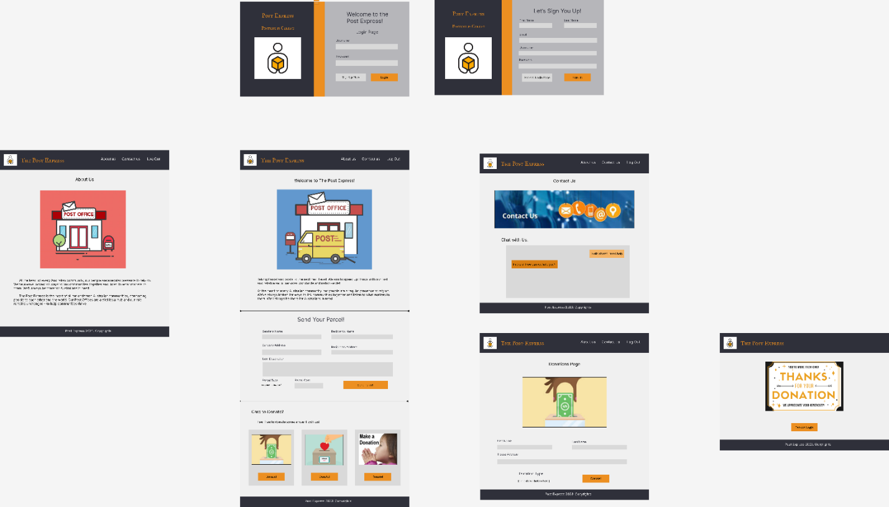

Please refer to this link on FIGMA: <https://www.figma.com/file/cqjL6jWBCHC0MjxnCF87My/SIT725-Group-Project?node-id=0%3A1&t=uPhN3mbFIRWsOYnS-0>

# External Interfaces

## User Interface

The primary way the user interacts with the system is through the web portal. The web portal is designed in such a way that it can be easily accessed through any browser. The system also consists of user support which will direct it towards the stakeholder’s support team. Furthermore, the user will be able to view, edit and cancel (based on terms and conditions from the stakeholder) the order and will be able to track their goods with location throughout the process.

## Hardware Interface

The user's device should consist of a minimum of 1 gigabyte of RAM. It is recommended that the user uses the latest version of their operating systems along with processor and memory. There is also no specification of the storage as the software is designed as a web application.

## Software Interface

The system will support Windows, Mac, and Linux environment. They will also support all sorts of modern browsers. The storage of the data of the system will be in a data warehouse designed in MongoDB and can be queried through SQL queries.

## Communication Interface

The basic communication interface of the software would be email and phone. There is also an option for SMS interaction. Furthermore, users can interact with the support team easily through emails.

# Online good Delivery and Tracker Features

## Login Management

This feature will allow both existing and new users to access their account and use other app features after successful login. Existing users will login into their account whereas new users will register and then can use their account. New users need to include the basic information to create the account like emails, phone number, address, and date of birth among others. There is an inclusion of resetting the user’s password if forgotten through a “Forgot you Password” feature.

## User Management

This feature will allow existing users to manage their account. Users can change their address, password, or phone number with a verification from both the user and the system. Furthermore, the user will be able to investigate their order history with various categories like fulfilled order, unfulfilled order, cancelled order etc.

## Payment Management

Whenever a user places an order from the system, the user will be shown the total cost for their order. The system requires a page that securely allows users to pay the amount and allows users to save the payment description for further use. This purpose will be fulfilled by the payment management system. The user will be able to view, edit and cancel their order. However, there will be time management which will not allow users to edit or cancel 4 hours after the booking time.

## Delivery Management

This is essentially the most important feature for the whole system. The main purpose of the system is to transfer user’s mail and parcels from one place to another safely and conveniently. For this we need to manage the delivery system. After the user places an order, a receipt is generated for the delivery team that will be assigned for the pickup and drop-off of the goods. If the delivery is within 50 KM from the user’s location, then a driver will be assigned where the user has the option for immediate delivery or schedule a delivery. If the delivery is above the 50 KM radius, then the company’s courier service provider will be assigned and will pick up the order. Once the order is picked up the courier facility will decide to send the goods by convenient means of transportation. Users will also have the option to deliver into the participating facilities.

# Use Case Diagram

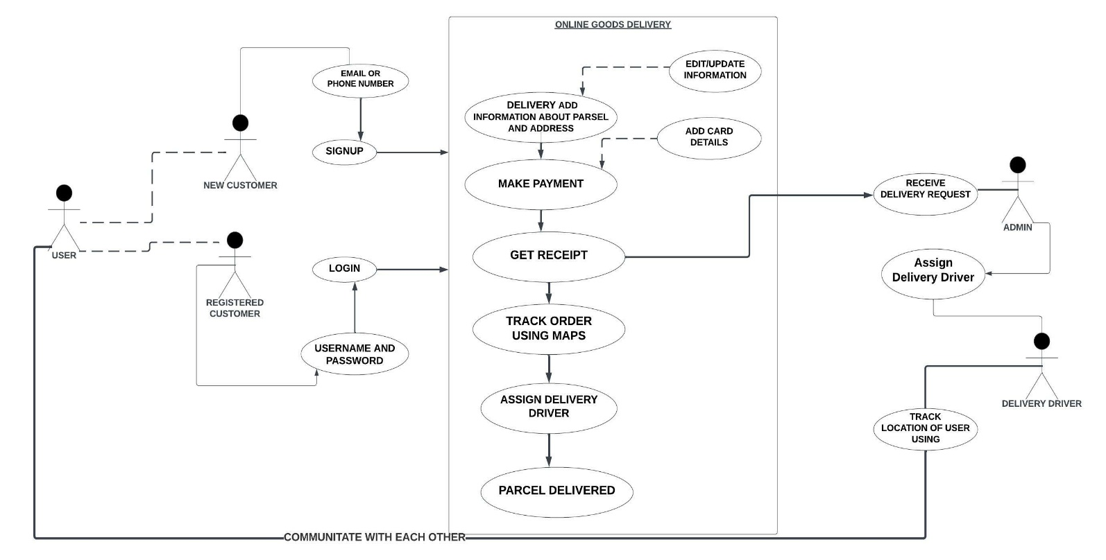

# Class Diagram

(Under Development)

# Sequence Diagram

# User Stories

1. Login Management:
   1. User story: As a customer, I want to create an account in the online delivery app and login into my account.
   2. Acceptance Criteria:
      1. A user cannot create an account without providing a valid password, email, and phone number.
      2. A user can access through various web browsers and different operating systems.
      3. A user should be able to change the password incase if they have forgotten the original password.
2. Creating a Parcel Form:
   1. User Story: As a customer, I want to have an online form (rather than waiting for a hard copy) so that I can provide to the post office with my mail and parcel. Once I complete the parcel, I will be given the receipt filled with all the details needed by the post office.
   2. Acceptance Criteria:
      1. I will fill in my information as a sender of only my name, Mobile No., and House Address.
      2. I want to fill in the information of my recipient with his name Mobile No., and House Address.
      3. I want to also select the type of parcel package I want to select and the cost of the package.
3. Payment System for Goods:
   1. User Story: As a customer, I want to securely pay the required bills for the order.
   2. Acceptance criteria:
      1. The payment system should accept various types of cards like credit, debit, eftpos, etc.
      2. Users can enter the card details and can save it for future use.
      3. The payment system should be able to identify invalid cards and can alert the user regarding their use.
4. Payment System for Donations:
   1. User Story: As the admin of the website, I wish to help many charities and NGOs with the amount of change I have and the customers who intend to do the same. I want the website to provide these options of charities to all the beloved customers who use our platform.
   2. Acceptance Criteria:
      1. I want the customers to have options of the charity they wish to donate to. I want them to be displayed on the main page of their account.
5. Location Tracking:
   1. User Story: As a customer, I can select various locations for delivery of goods.
   2. Acceptance criteria:
      1. The system should ask the user to allow them to track their location.
      2. The user can use various locations.
      3. This feature should be included in the delivery driver as well.
      4. A good UI should be used for this feature so that the user can have a user-friendly interaction with this feature.

# Wireframe

## Login

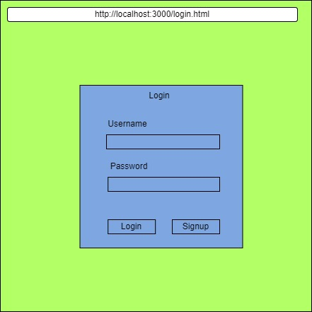

## Signup

## Homepage

## Payment

# Lo/Hi Def Prototypes

## Login

## Signup

## Homepage

## Payment

# Non- Functional Requirements

The following are some non-functional requirements within the system:

* The software will ensure that the sensitive information collected from the users is protected.
* The software does include a huge amount of storage with a plan to expand it with the increasing demand.
* The software can be used anytime and is available 24/7. It would be designed with lots of testing against huge network traffic and how to control it.
* The software will be kept under regular maintenance along with new feature development.
* The software will be easy to use and will consist of 24/7 support through email.
* The response time of the software is exceptional and can give out the results within a minute.

# Other Requirements

* The software will be available in English language but will have a development of other additional language in it.
* The software does follow the policies for database integrity such as Risk-Based Validation, plan for business continuity, accuracy, and archive and among others.
* The software does support all the operating environment.
* The software does also follow the guiding principles of building an application and design.

# Dependencies

For the development of the project, we will be using JavaScript as the main language for the back end and front-end along with HTML and CSS (front-end). We will be using MongoDB for the database connection and queries will be performed in Structure Query Language (SQL). We will be using the SHA-256 to encrypt user sensitive information like phone number, user password and email. Furthermore, a log history will be maintained in a text file to investigate the performance of the system and catch crashes if any occurred.

# Risks

Since this is an early development and if this were to deploy into the internet, these are some of the risks I would be facing:

* Privacy issues of users and the risk of the accounts getting hacked.
* The risk of money payments not being secure and can be availed by a malicious adversary.

# Conclusion

The following project shows everything you need to know about the entire project before the start of the project. This document describes what the entire project is in a nutshell, and then expands onto all the amazing features it has. Firstly, it describes all the operations which the website possesses. The website can also describe how the user will be interacting with the website and what he will get as a result. It also describes some of the possible constraints the first website can experience at first, which can later become better over time. It also shows some of its outstanding attributes which can be compelling from a business perspective.

# References

* <https://diceus.com/custom-software-requirements-specification/>
* <https://trello.com/b/m9tTR57X/project-sit725>
* <https://copyassignment.com/courier-tracking-system-in-html-css-and-js/>
* <https://github.com/loveraj16/courier-management-system>

# APPENDIX-1: Project Delivery

## Prastut – Contribution

### Key Contribution

* + Creating and assigning tasks to the team.
  + Development of features for the system.
  + Creating Sprint planning and retrospective.
  + Story boxing the user stories.

### Reflection

* + Project development has been started.
  + The group has been following the agile development cycles despite everyone’s tight schedule which shows great determination and dedication towards the project.
  + Teamwork could be seen even early towards the development.
  + The project also consists of features that are to be researched and has helped developers to build projects through R&D (Research and Development) lifecycle.

### Git Contribution

A git environment to store the project code and documentation is yet to be developed.

### Trello Contribution

The Trello board has been created where each user is assigned one task. There are some tasks that are to be done in a group. Each task has been given a maximum of 7 hours to complete (which is equivalent to 3 story points in agile development). Task has been created with user stories and has been given some checklists for completion.

### Completed User Story

* + Payment Management

### Worklog

* + December 29th, 2022- 2 hours in creating the Trello board and cards.
  + January 3rd, 2023 – 2 hours in researching on the payment system management.
  + January 6th, 2023 – 4 hours in creating and editing the SRS documentation.
  + January 9th, 2023 – 3 hours in designing the skeleton view of the payment system.
  + January 13th, 2023 – 4 hours in designing the front-end of payment system including CSS.
  + January 15th,2023 – 2 hours in managing Trello Board.
  + January 18th, 2023 – 3 hours in maintaining git by creating branches and source codes.
  + January 21st, 2023 – 2 hours in designing sequence diagram.
  + January 22nd, 2023 – 2 hours in designing wireframe diagram and lo/hi def prototype.

## Muhammad – Contribution

### Reflection

“The beginning of this project consisted of various team discussions and planning. Initially, everyone researches what makes of this website and what kind of feature we should be adding. I have managed to design the website in Figma, and I was able to share some insight with my friends of how the website will look like. I am now more aware of the website will look like after discussing with my team and now I will be able to work accordingly as my given role in the team.”

### Worklog

* + Researching on the features of the project. (4 hours)
  + Created the front-end prototype design on Figma. (4 hours)
  + Documentation of the SRS Document. (6 hours)

## Komaldeep – Contribution

### Reflection

“I have managed to design the login and signup page. After discussing with my team, I am aware now how the login and signup page will look like. Now I can work accordingly as my role in the team task.”

### Worklog

* + Researching on signup page design. (2 hours)
  + Created login page design still adding more things. (4 hours)
  + Documentation of SRS document. (4 hours)

## Azmah – Contribution

### Reflection

“When it comes to modern web applications, interactions often need to be done in real-time. When the team decided to add tracking of order details in a map, I started to do research on Google map API and Geolocation. And managed to find how to develop the map with location tracker in the Web application. As the next step I'm planning to start the initial development of the Map section and do more research.”

### Worklog

* Research on the technologies used to develop location tracking in web applications (2 Hour)
* Research on Mongo DB connection to Location based web application and possibilities of tracker (2 Hour)
* Documentation of SRS document. (4 hours)